Key Terms |  | Core teachings
Diversity | The concept of diversity encompasses acceptance and respect. It means understanding that each individual is unique, and recognizing our individual differences. These can be along the dimensions of race, ethnicity, gender, sexual orientation, socio-economic status, age, physical abilities, religious beliefs, political beliefs, or other ideologies. It is the exploration of these differences in a safe, positive, and nurturing environment. It is about understanding each other and moving beyond simple tolerance to embracing and celebrating the rich dimensions of diversity contained within each individual. | The Big 6  Buddhists believe that we should not cause suffering and by not being kind to people we are causing suffering (dukkha). They believe in Karma and that positive actions result in positive karma where as negative results in negative. They also teach that karuna (compassion) and Metta (loving-kindness) are important.  Christianity teaches that you should ‘Treat others as you want to be treated’ and should ‘love thy neighbour’ Christians follow the example of Jesus who was caring to all people.  Sikhs can belong to the Khalsa a group of Sikhs who wear the five K’s (five items that symbolise their faith)/  “The God-conscious being shows kindness to all. No evil comes from the God-conscious being.” (guru granth sahib)  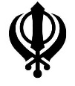  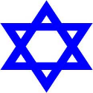  “Thou shalt not take vengeance, nor bear any grudge against the children of thy people, but thou shalt love thy neighbour as thyself: I am the LORD.” (Leviticus 19:18)  “This is the sum of duty: do not do to others what would cause pain if done to you.” Mahabharata 5:1517  "Anyone who does not show mercy to our children is not one of us” (prophet Muhammad)
Multi-faith | Multiple religions living together in society.
Multicultural | Multiple cultures living together in society.
British Values | A set of rules governing British society. Democracy, The rule of law, individual liberty, mutual respect, tolerating diversity.
Discrimination | Treating people less favorably because of their race/gender/colour/class/religion.
Religious Tolerance | To accept and permit other religions even if they go against your own beliefs.
Stereotypes | a widely held but fixed and oversimplified image or idea of a particular type of person or thing
Racial harmony | Different races/colours living happily together in society.
Prejudice | Believing some people are inferior or superior without even knowing them.
Key Spellings |  | Weblinks | Key information
 |  | https://youtu.be/hfO82z29hWg - What is diversity | Democracy  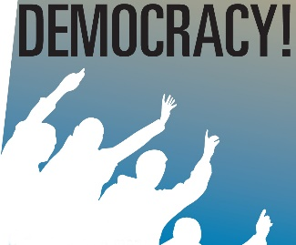  - This is a type of government where the people of a country hold the power to rule by electing representatives.  The rule of Law  - This is part of the British Constitution and is a fundamental part of British Politics. It involves:  - The rights of individuals are determined by legal rules. No punishment can be applied without a court ruling that a law has been breached  - Individual liberties depend on it. All trials must be ruled by a jury and impartial judge.  Individual Liberty  - These are the basic rights and freedoms.  Mutual Respect  - When two or more parties respect each others’ opinions.  - Britain adopt a “Code of Mutual Respect and Cooperation” by doing things such as treating everyone equally  Tolerating Diversity  - Celebrate differences and value everyone, despite their:  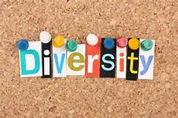  - Gender  - Ethnic background  - Religious beliefs  - Sexuality  - Disability
Key Questions
Is there such a thing as a perfect person?
What makes a person?
Why are some qualities more undesirable than others?
Why are we diverse?
Does everyone have equal opportunities?
Should everyone have access to equal opportunities in 21st Century?
Why are British Values important?

